1. **Run Sonarqube docker container**

**Docker-compose.yaml file**

version: "3"  
  
services:  
 sonarqube:  
 image: sonarqube:community  
 depends_on:  
 - init  
 - db  
 environment:  
 SONAR_JDBC_URL: jdbc:postgresql://db:5432/sonar  
 SONAR_JDBC_USERNAME: sonar  
 SONAR_JDBC_PASSWORD: sonar  
 volumes:  
 - ./data/sonarqube_data:/opt/sonarqube/data  
 - ./data/sonarqube_extensions:/opt/sonarqube/extensions  
 - ./data/sonarqube_logs:/opt/sonarqube/logs  
 ports:  
 - "9000:9000"  
  
 init:  
 image: bash  
 container_name: init  
 privileged: true  
 user: root  
 volumes:  
 - ./init/init_sysctl.sh:/mnt/init_sysctl.sh  
 command: [ "sh", "-e", "/mnt/init_sysctl.sh" ]  
  
 db:  
 image: postgres:12  
 environment:  
 POSTGRES_USER: sonar  
 POSTGRES_PASSWORD: sonar  
 volumes:  
 - ./data/postgresql:/var/lib/postgresql  
 - ./data/postgresql_data:/var/lib/postgresql/data  
  
volumes:  
 init:  
 data:

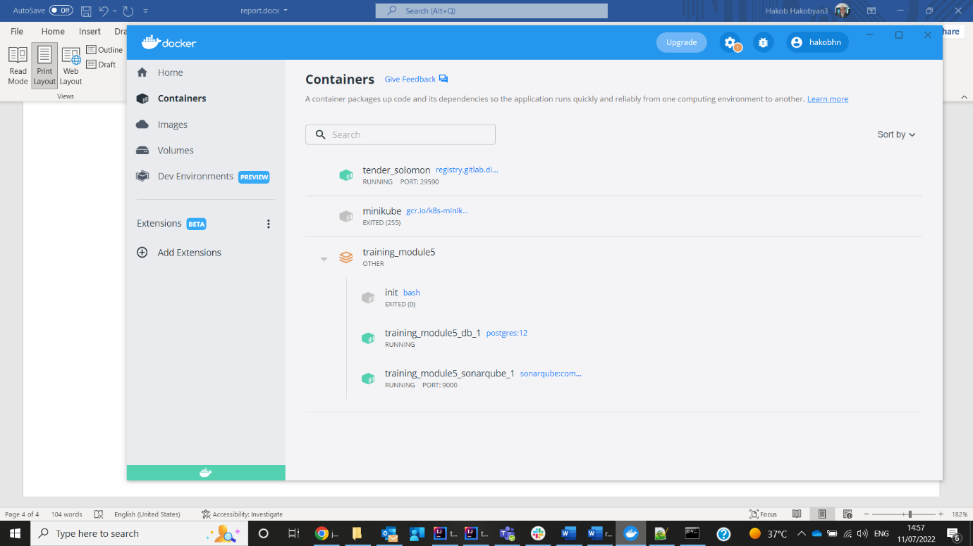

**After starting containers, sonarqube server started on port 9000**

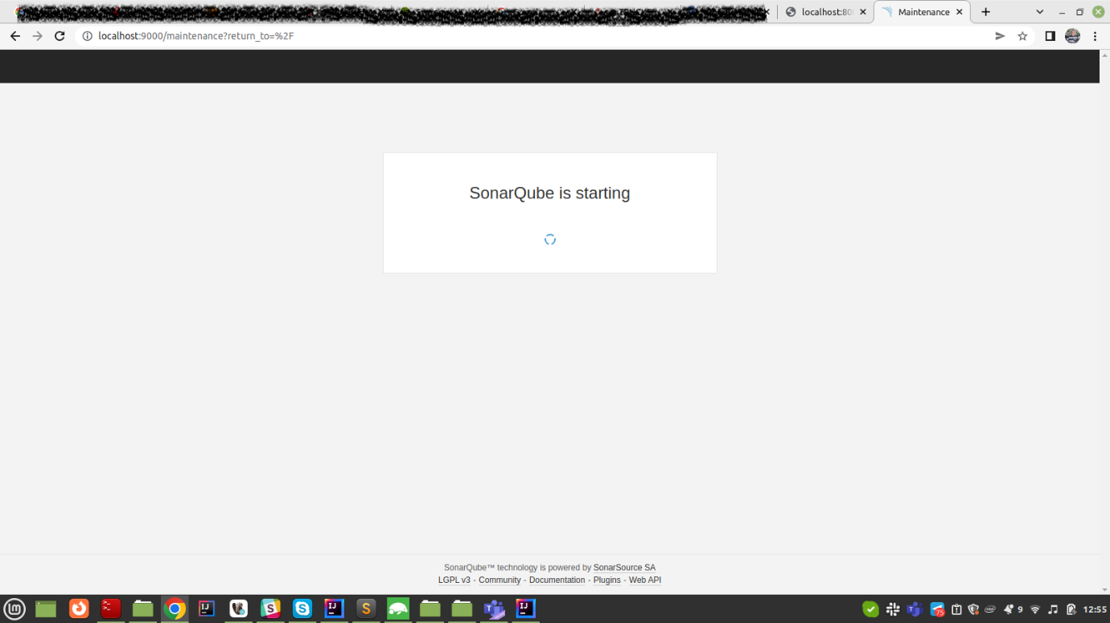

Need to setup new password for admin. Default password is admin

Choose previous module solution as application on which sonarqube analyzing prcessed.

Getting token for app

Command for run sonarqube for maven application:

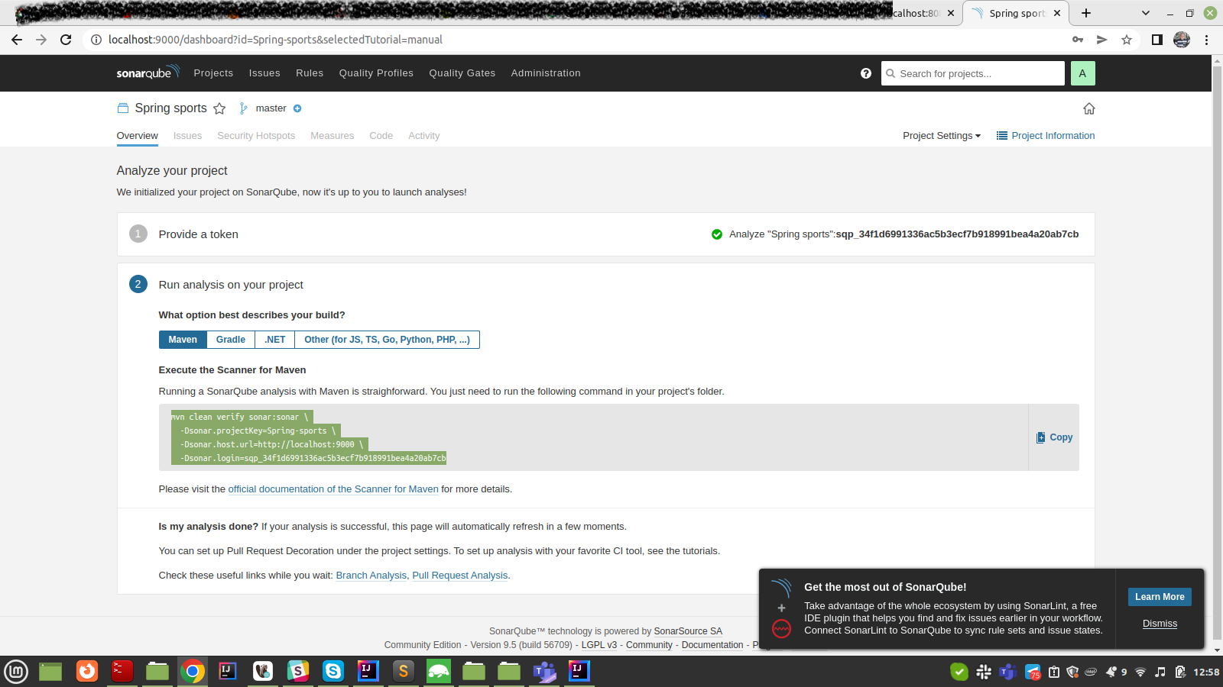

Setting up settings.xml file for maven config

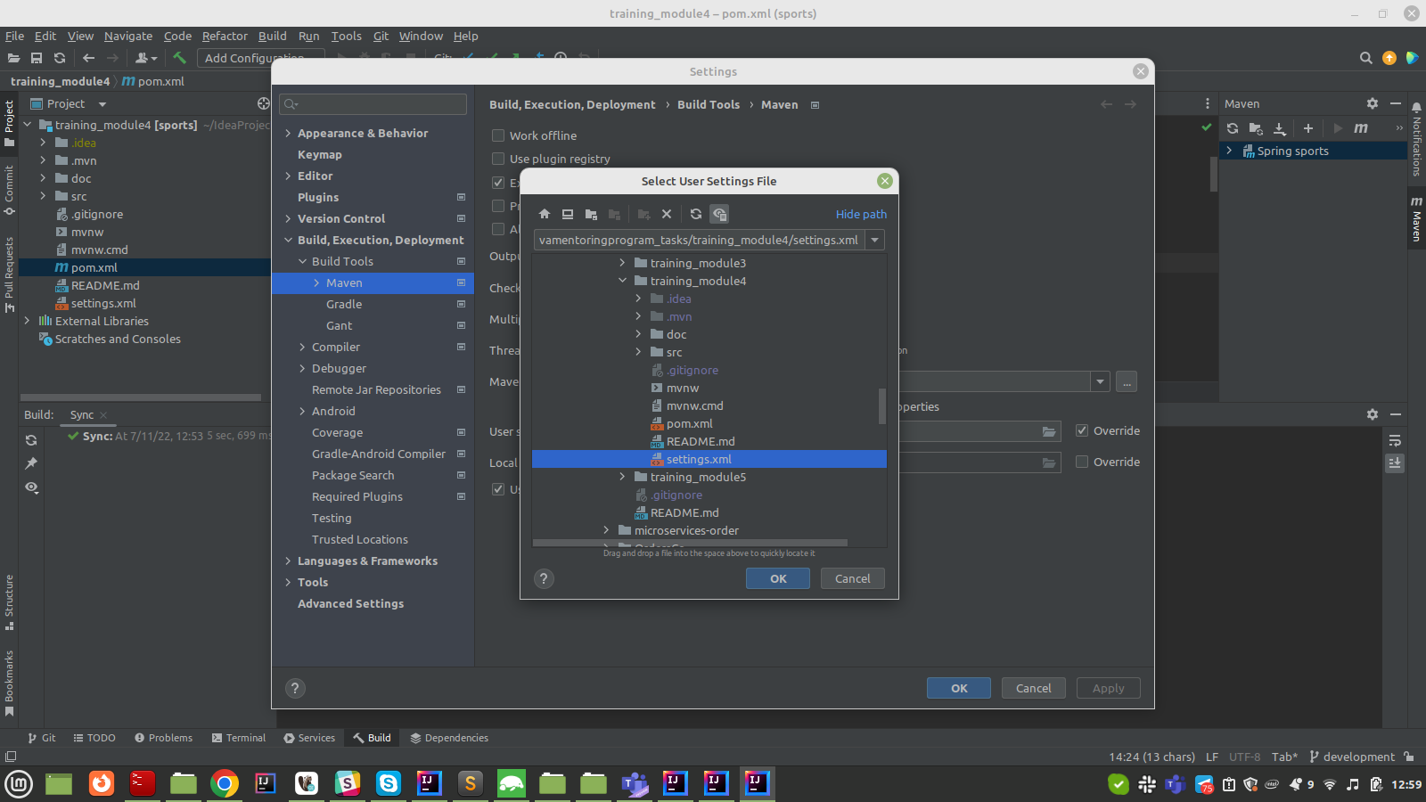

File content with run command in terminal:

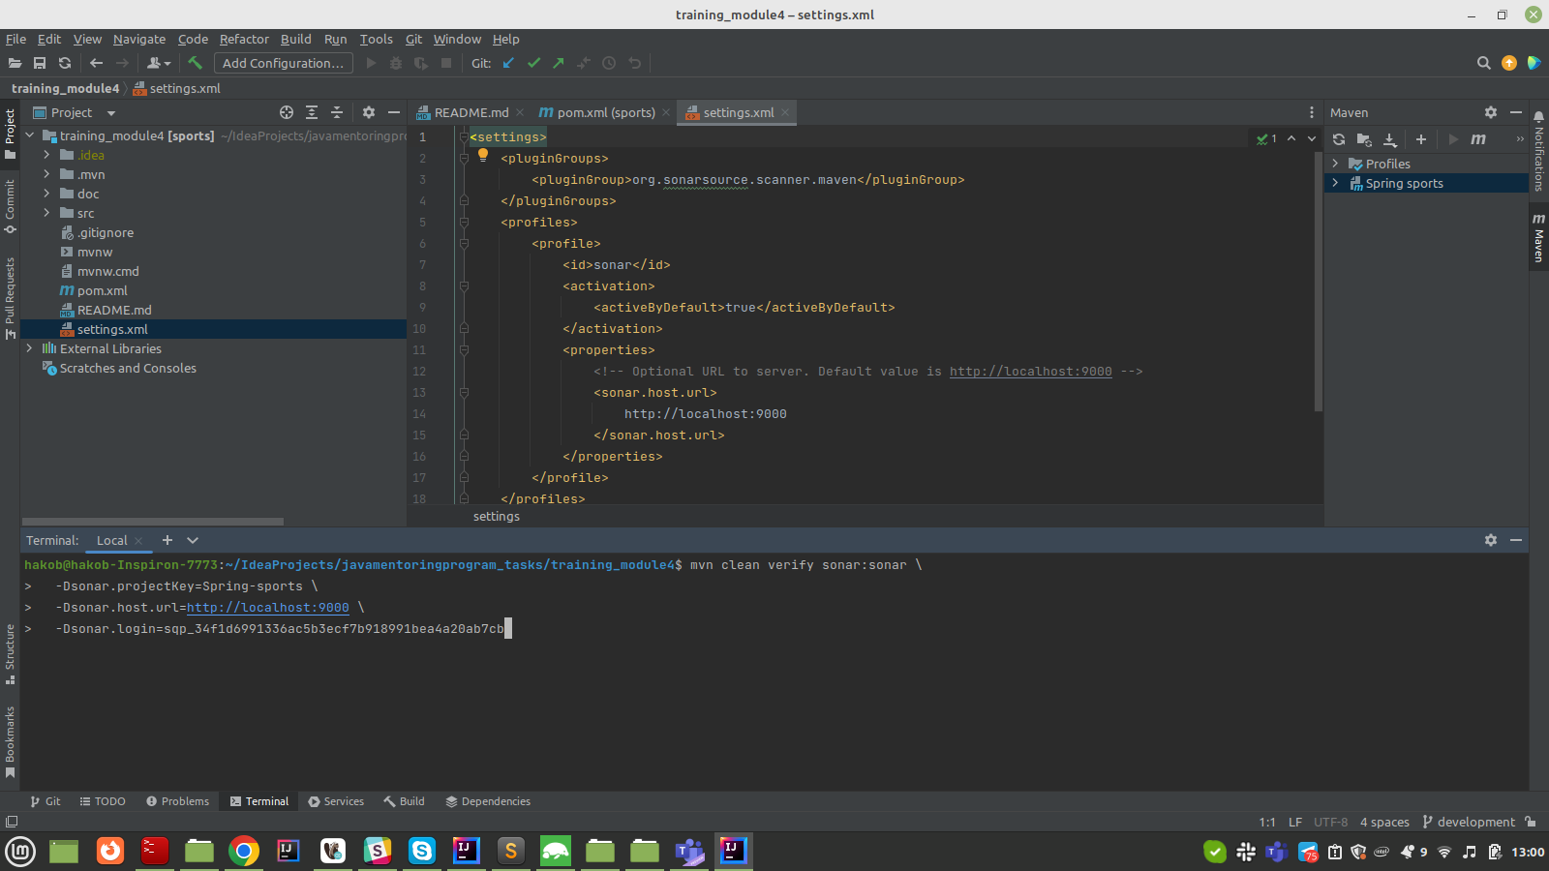

Maven verifying with sonarqube results:

Results in sonarcube web gui

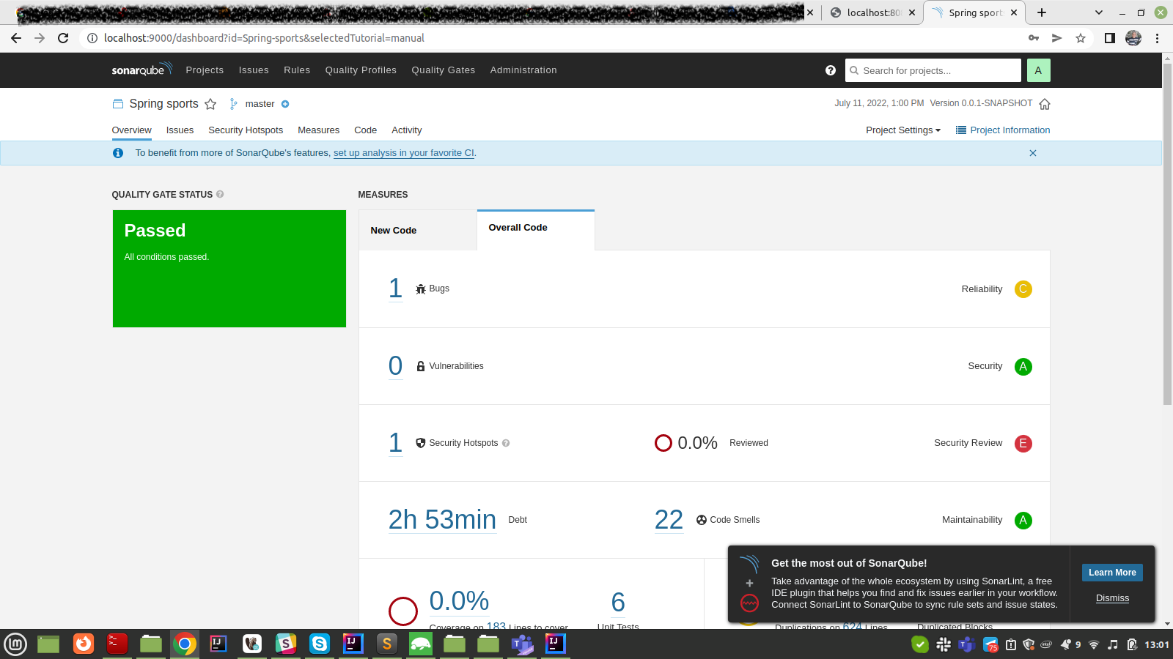

Different bugs, duplicates and smells found in analyzing results:

Fixing them

Another code smell found

Installing sonarlint for making process faster

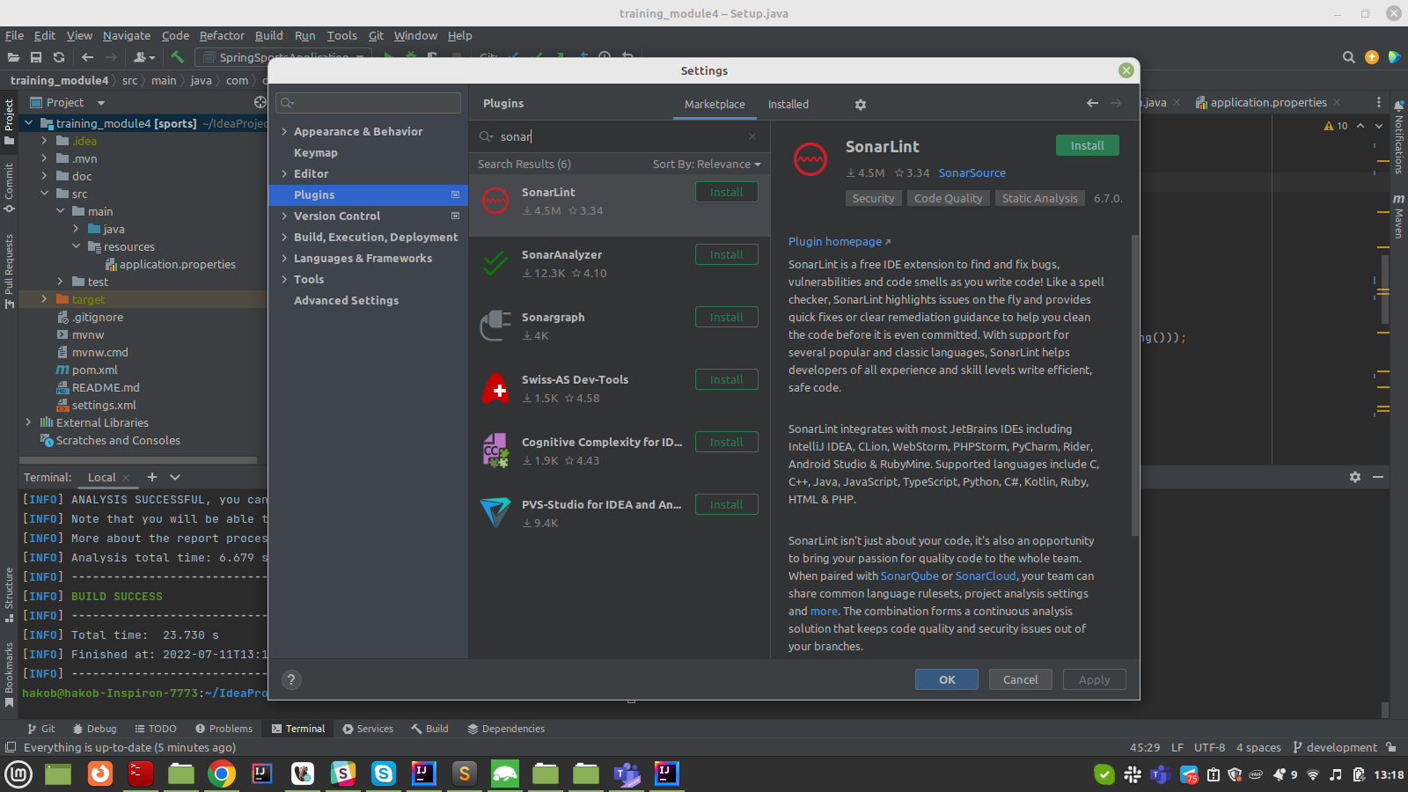

Analyzing with sonarlint

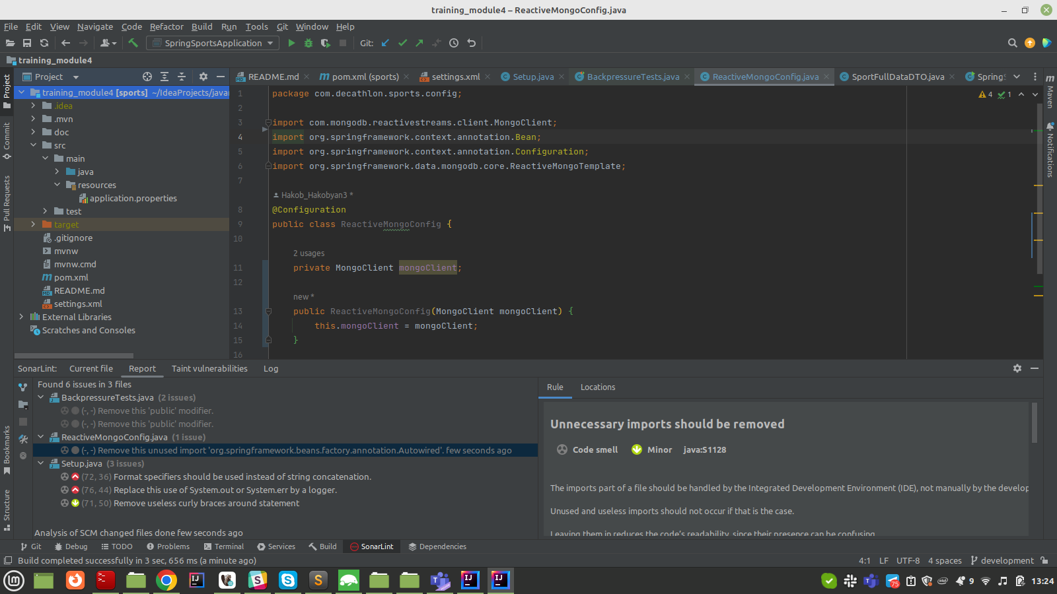

Fixing issues from sonarlint

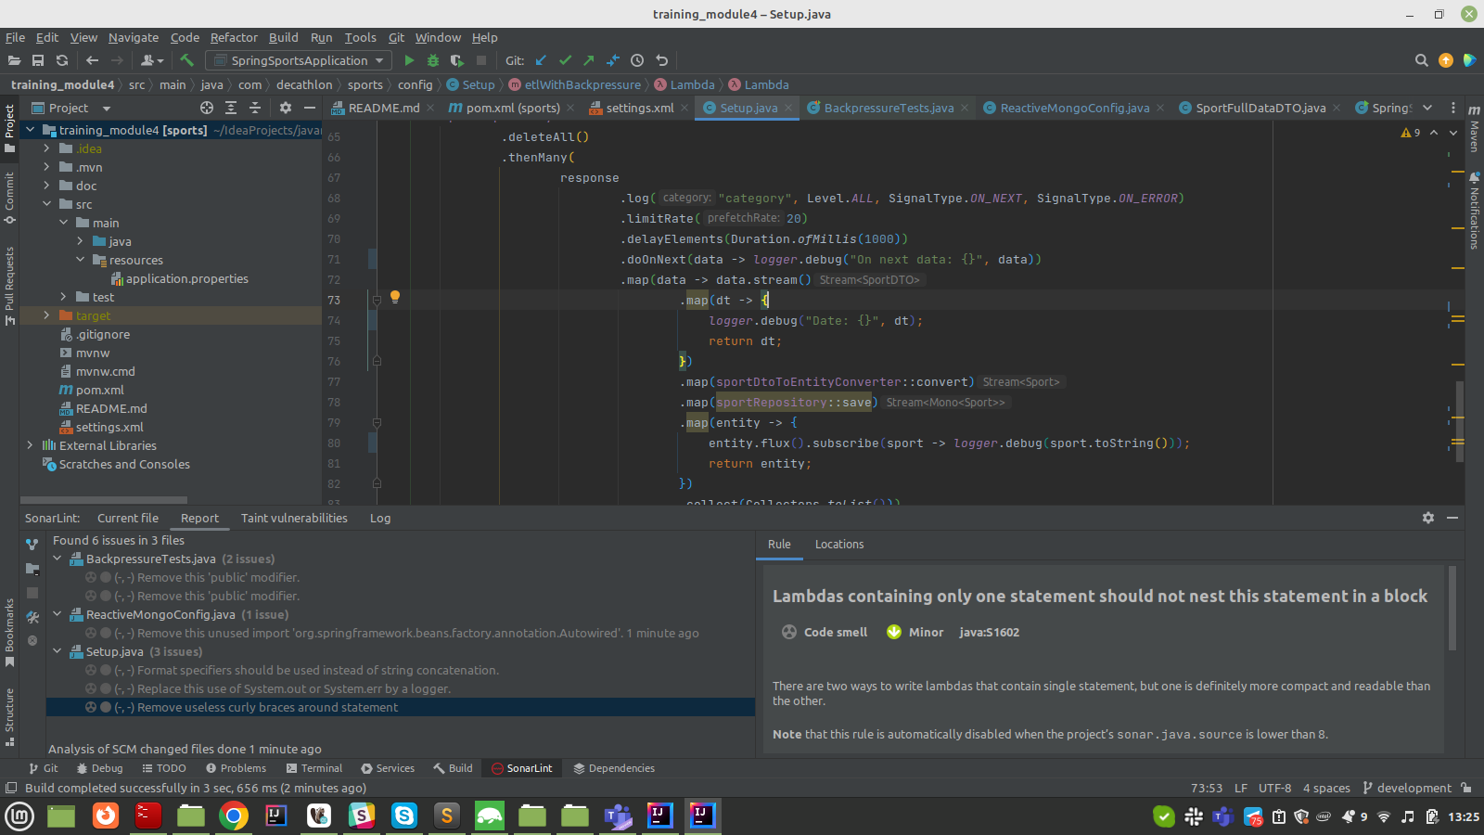

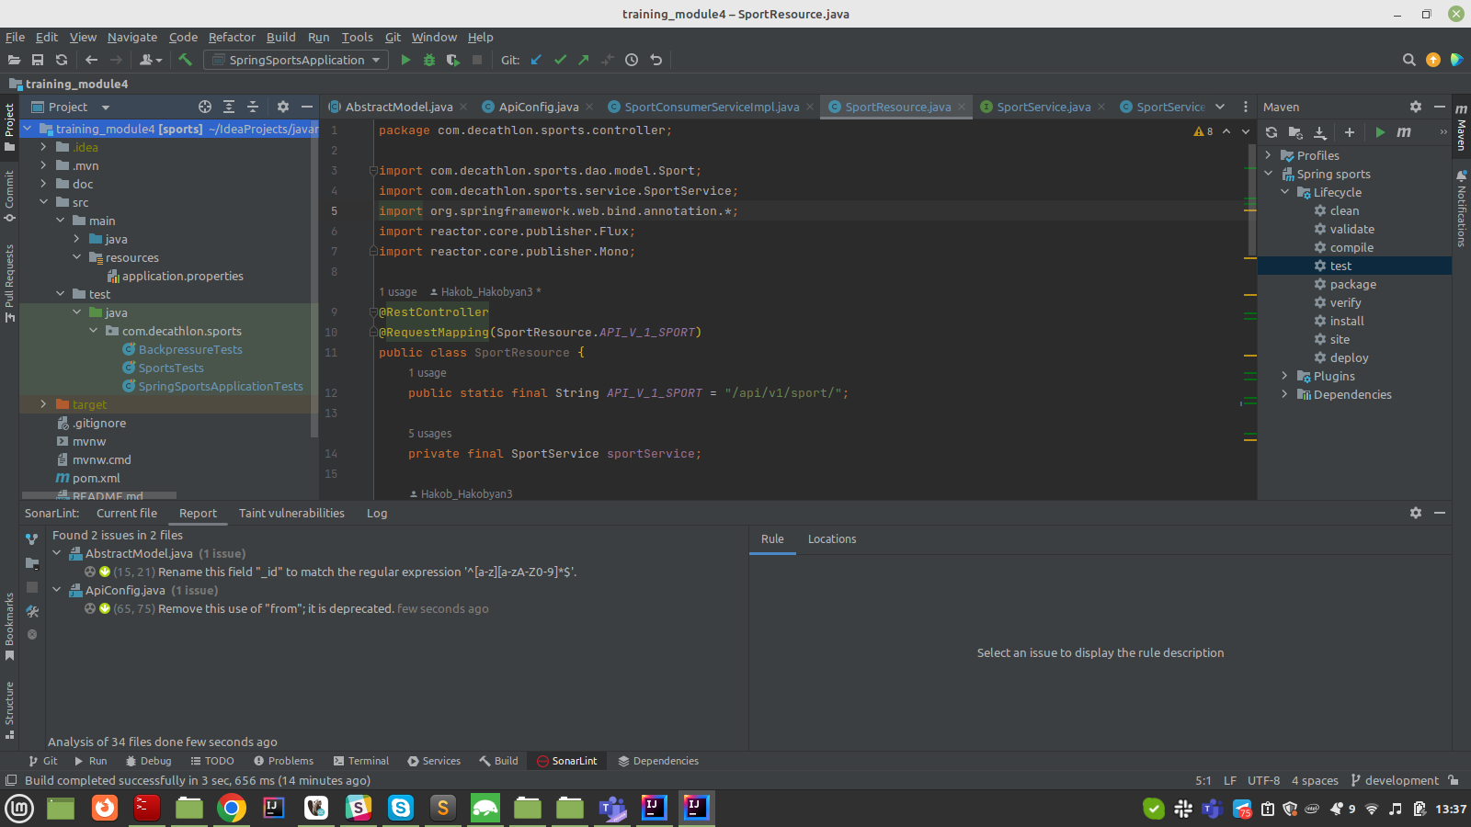

Running tests with checking coverage:

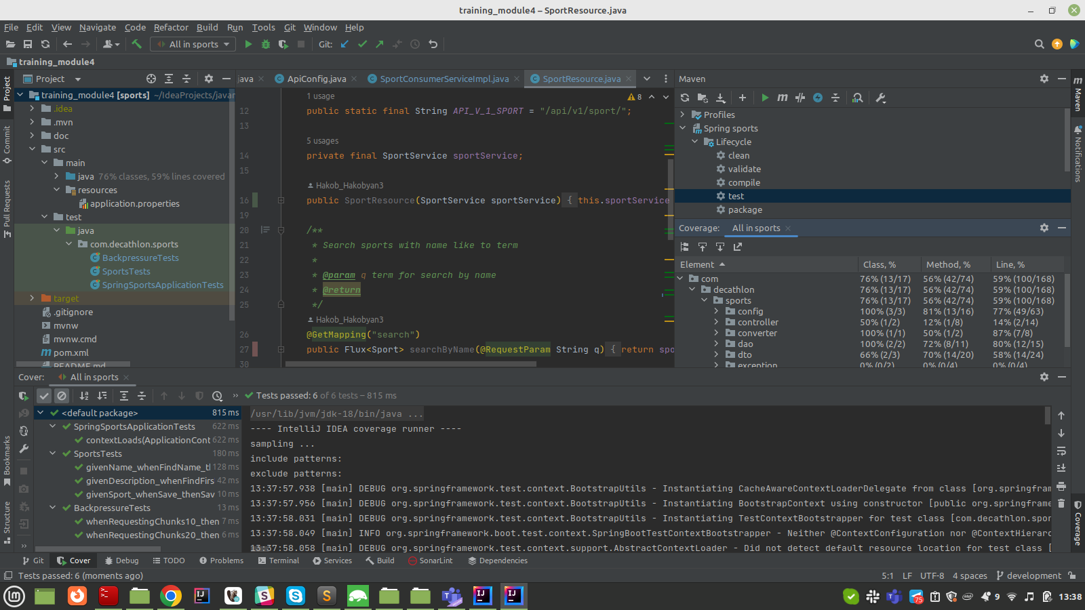

Current code analyze results:

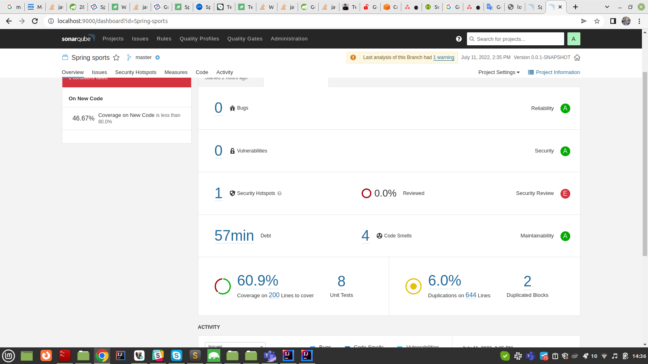

Setup quality gate

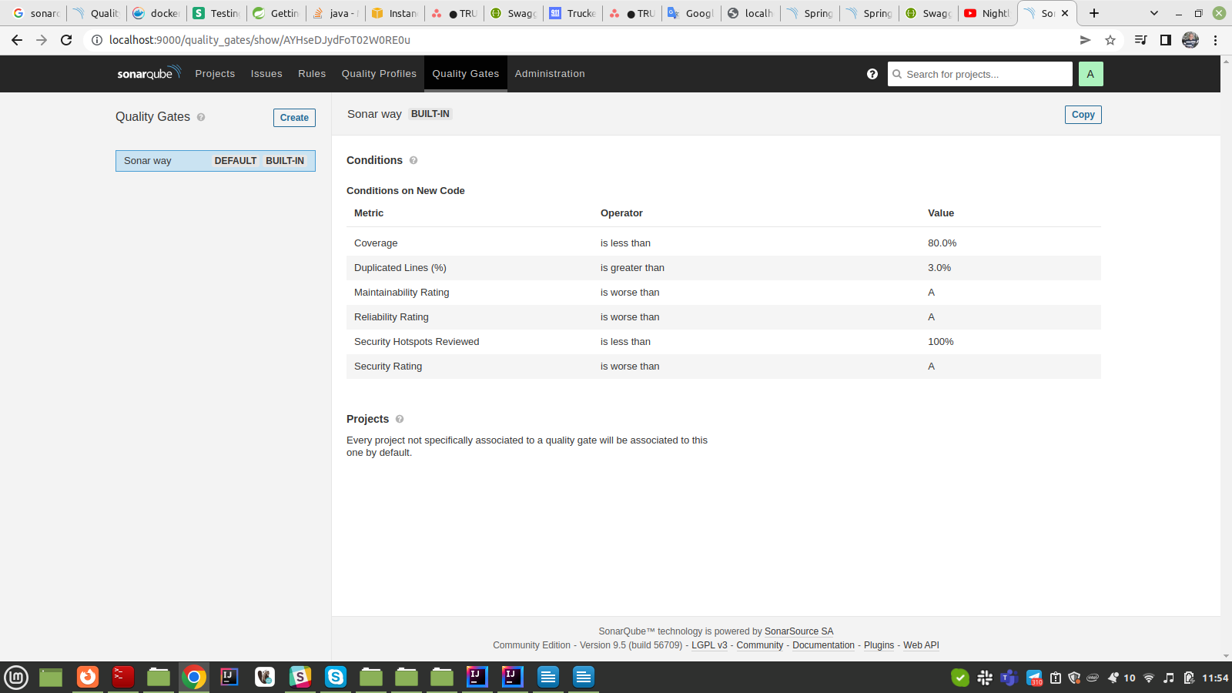

Increasing test coverage for service layer and for REST calls

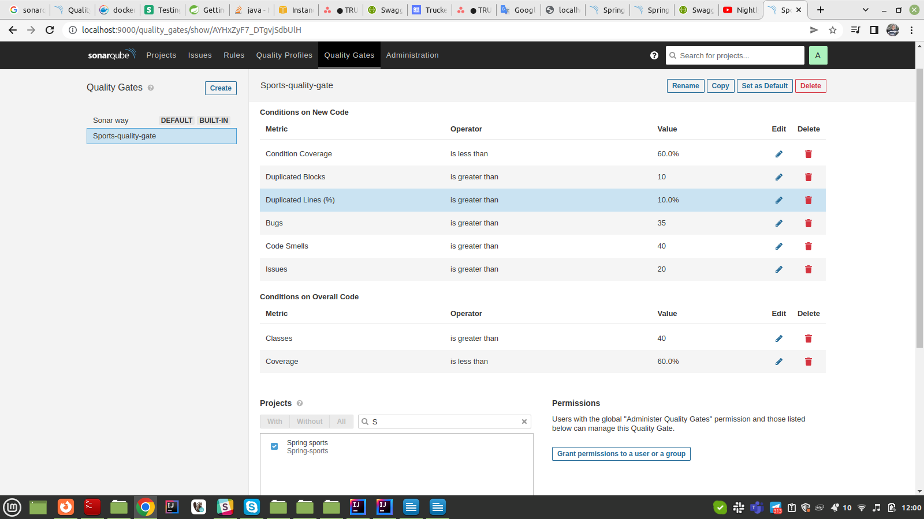

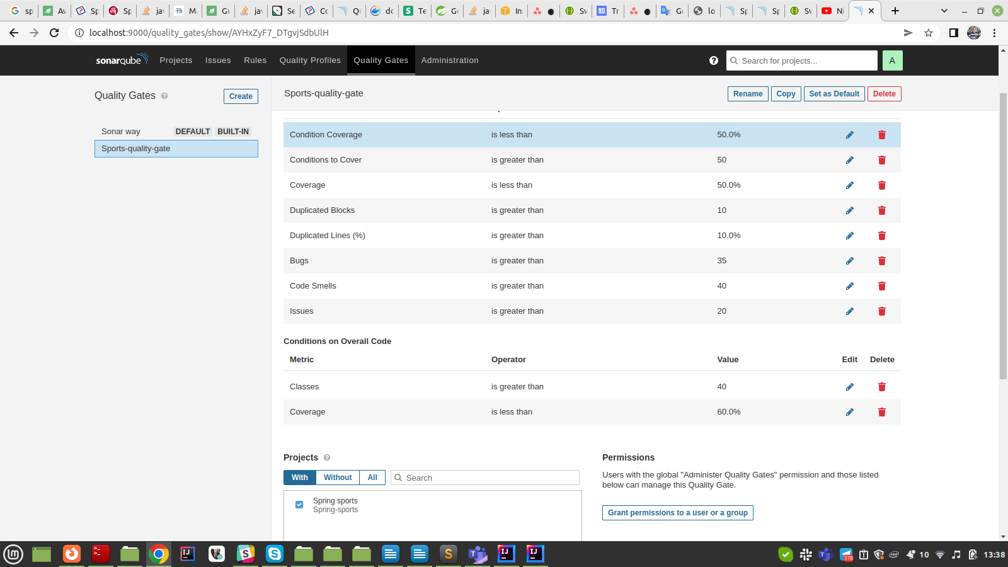

Result of coverage

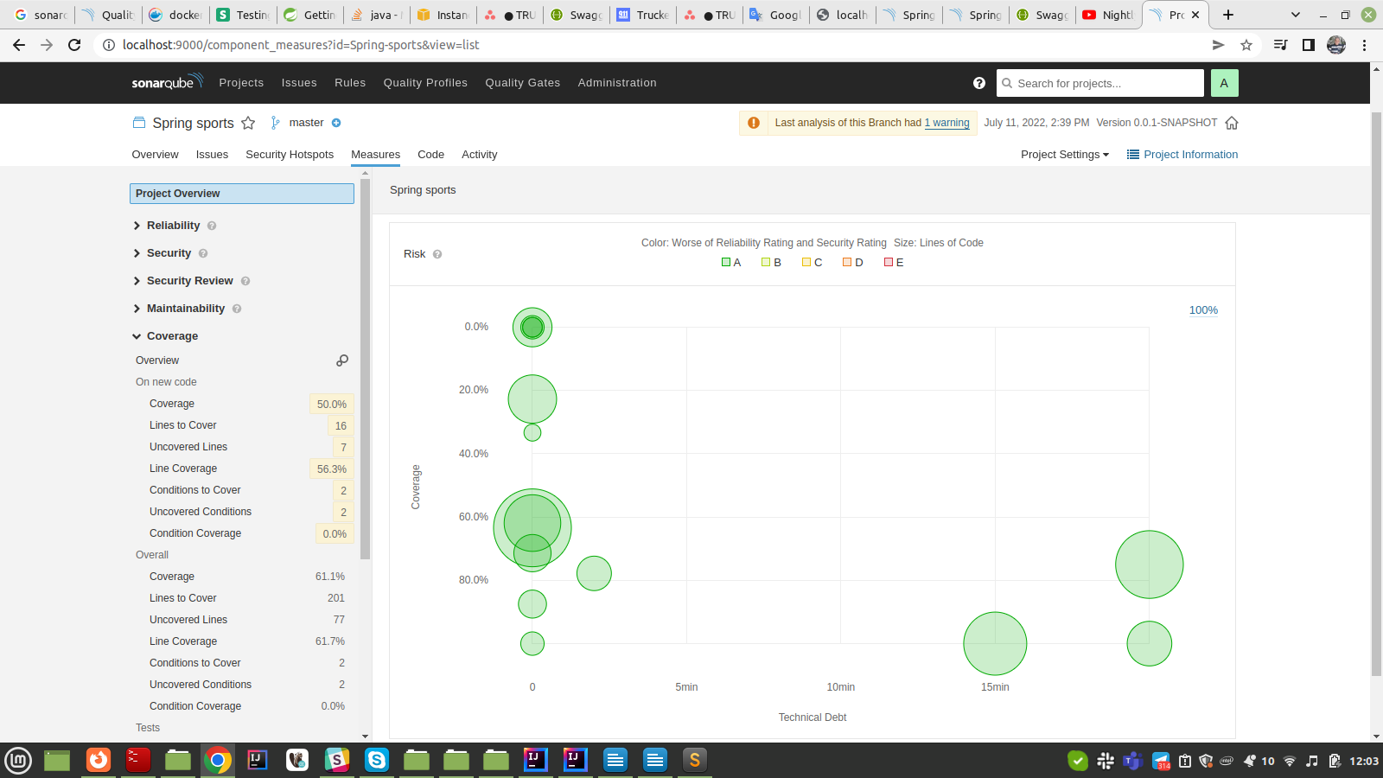Improving test coverage, adding new test for service layer and for REST calls

